

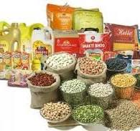

https://www.indiamart.com/proddetail/all-grocery-items-22523131473.html?mTd=1

https://www.indiamart.com/?back=1